Complete guide to building an app with net core and react





.dotnet core sdk 3.x

dotnet –info

dotnet –version

* node.js ( <https://nodejs.org/en/>)
* Installing node.js with NVM ( <https://medium.com/@Joachim8675309/installing-node-js-with-nvm-4dc469c977d9>)
* Install git
* Vscode
* Vscode Extensions
  + Auto close tag
  + Auto Rename Tag
  + Bracket pair colorizer2
  + C# power by omnisharp
  + C# extension (jchannon)
  + Es7 React/Redux/Graph …
  + Material icon theme
  + Nugget package manager
  + Prettier code formatter
  + SqLite

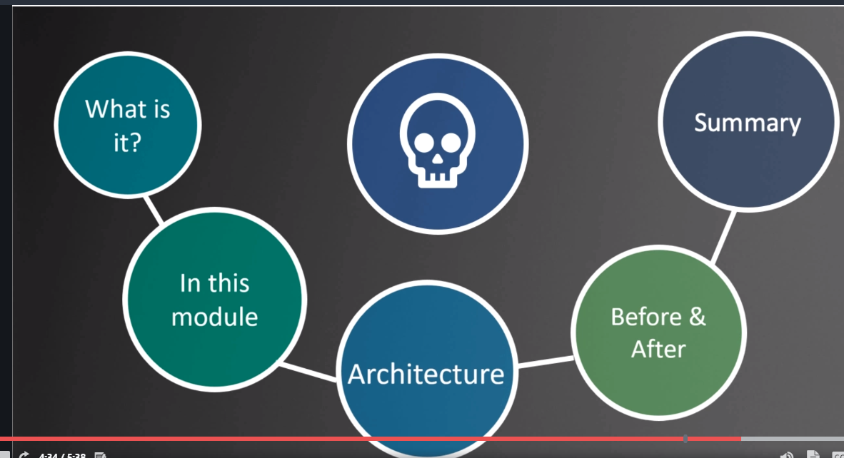

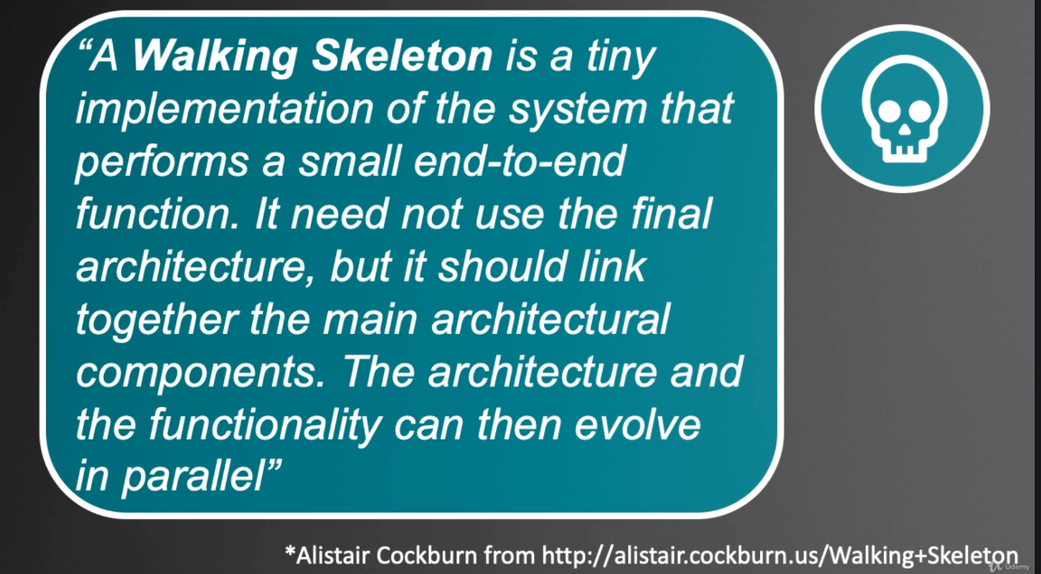

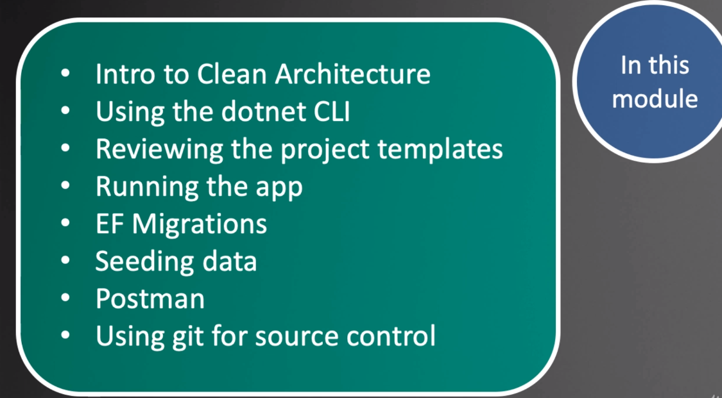

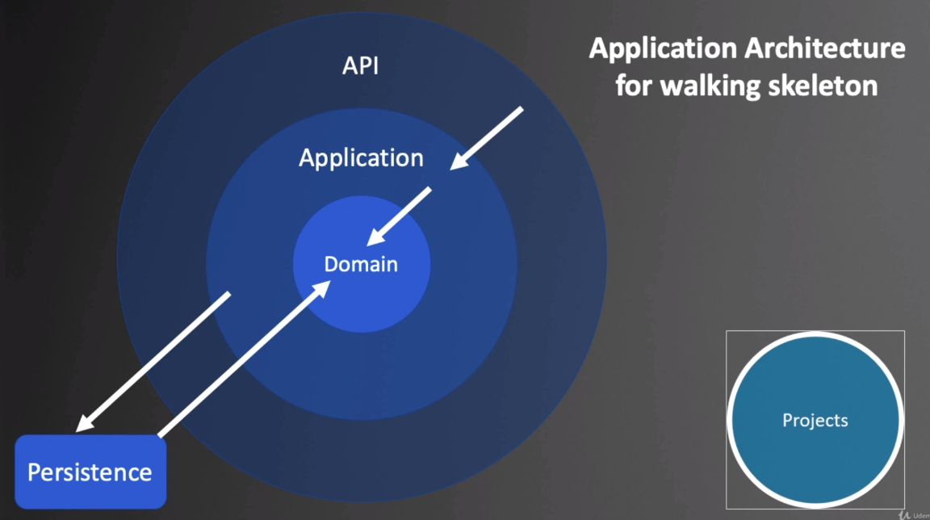

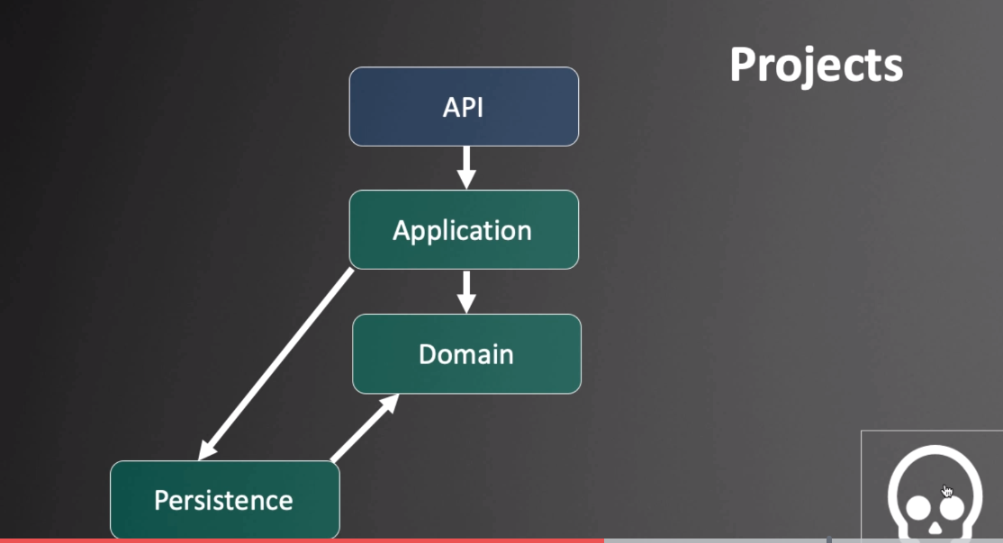

dotnet –info

mkdir Reactivities

dotnet –h ( list the command )

dotnet new –h

dotnet new sln ( will use the name of containing server for solution name)

dotnet new classlib –n Domain

dotnet new classlib –n Persistence

dotnet new classlib - n Application

dotnet new webapi –n API

Adding dependencies:

dotnet sln –h

dotnet sln add Domain/

dotnet sln add Persistence

dotnet sln add application

dotnet sln add API

Cd to the Application project use dotnet add reference …

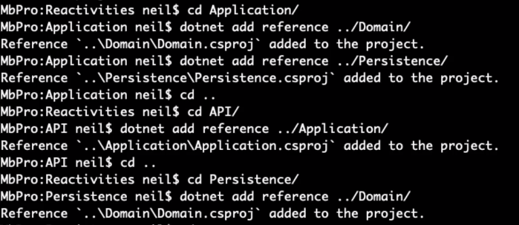

Exclude \*\*/obj , \*\*/bin etc

File->preferences search for the pattern

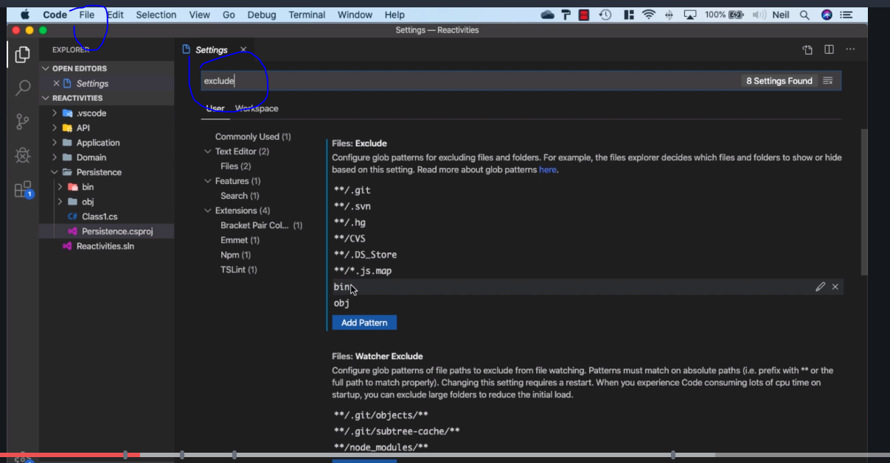

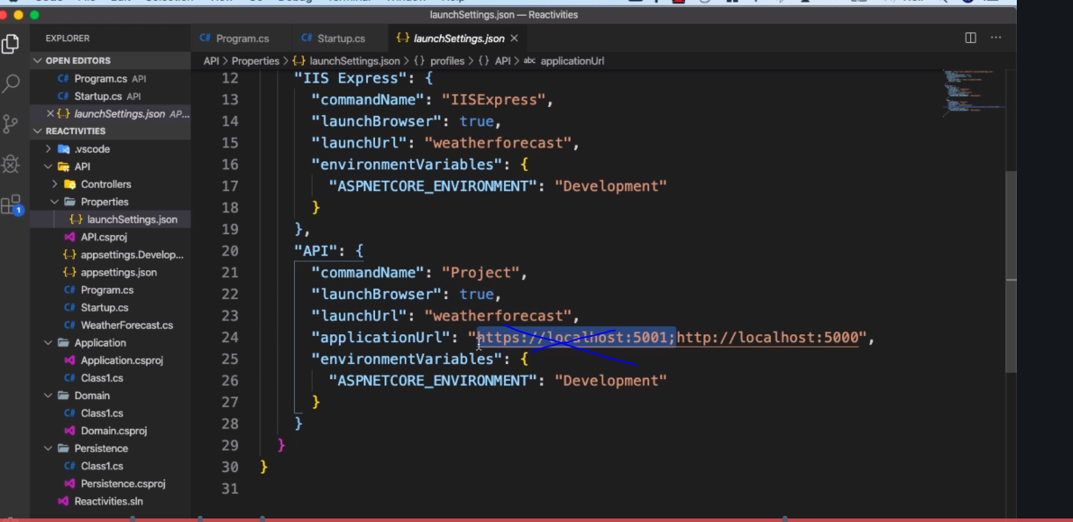

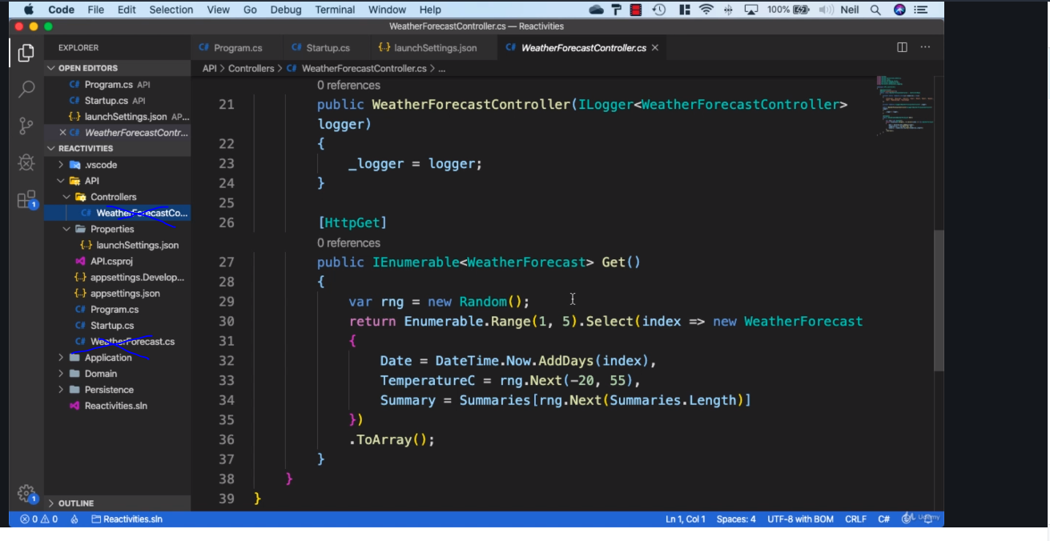

Run dotnet run at the startup level

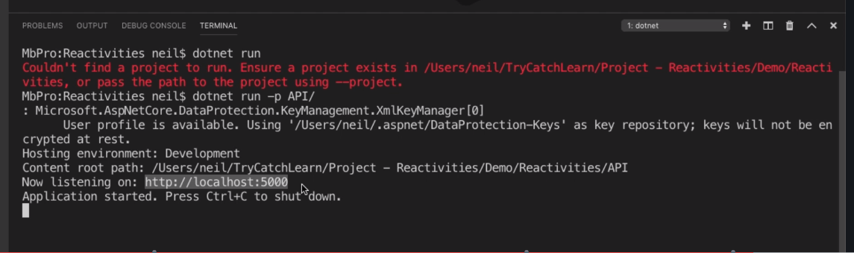

DBContext

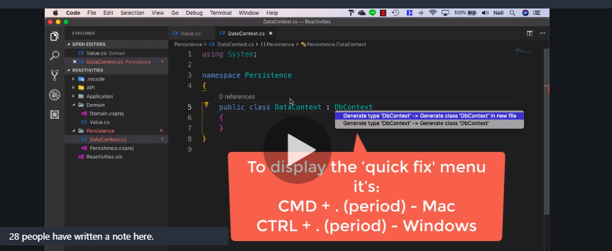

Add the

Microsoft.EntityFrameWorkCore

Microsoft.EntityFrameWorkCore.Sqlite

Microsoft.EntityFrameWorkCore.Design

Add entityframework tools

dotnet tool install --global dotnet-ef

dotnet ef

Got to the Root of the project

dotnet ef migrations add InitialCreate --project Persistence/ --stratup-project API/ (-p project – s startup project )

Install any reference and install them

Update Database manually or every time the program runs

Manually: dotnet ef database –update

Startup => program.cs

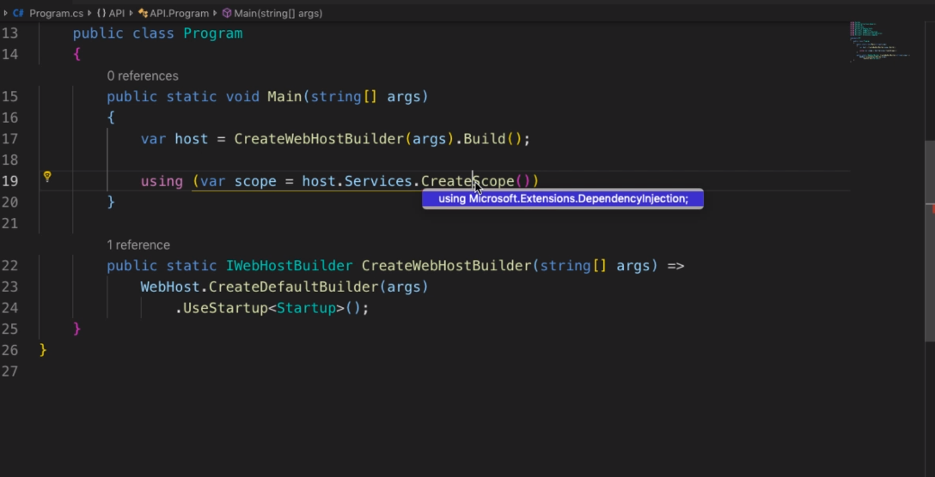

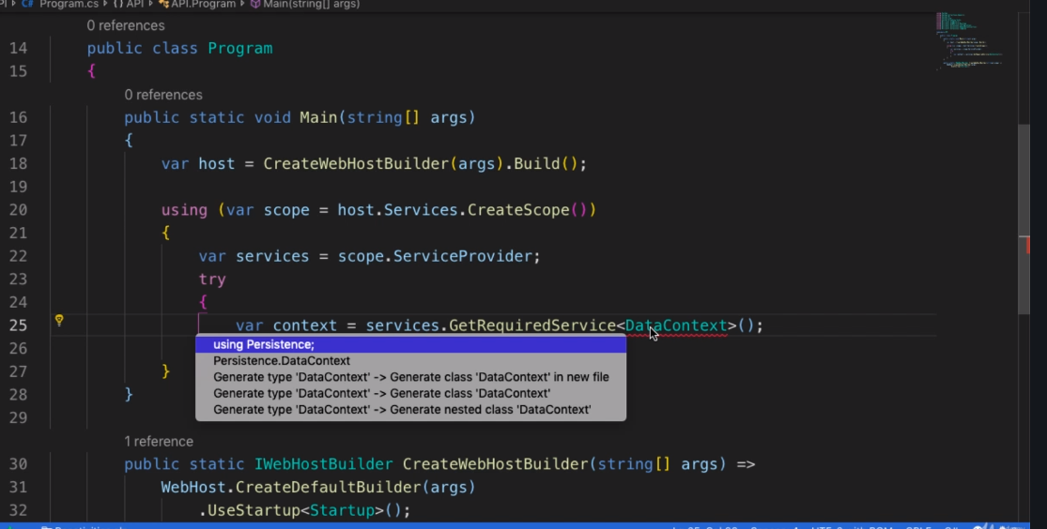

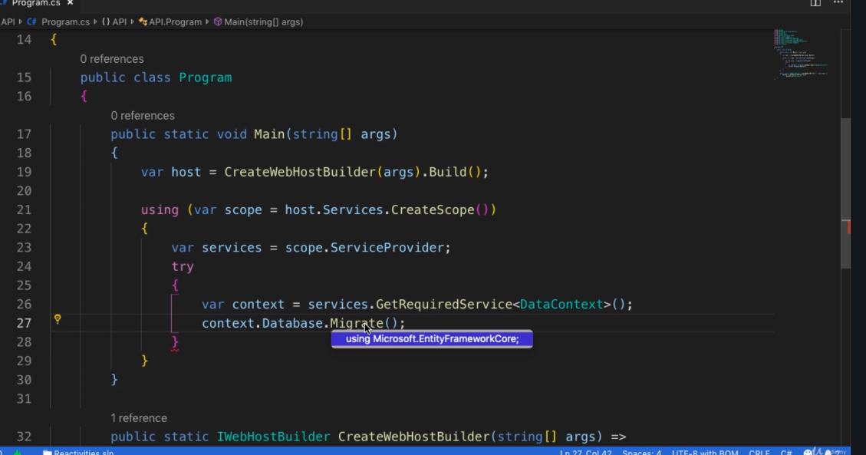

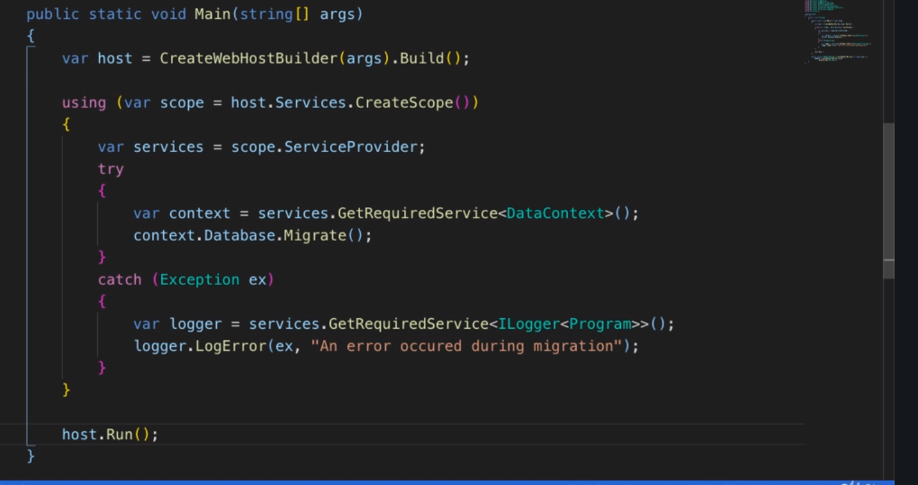

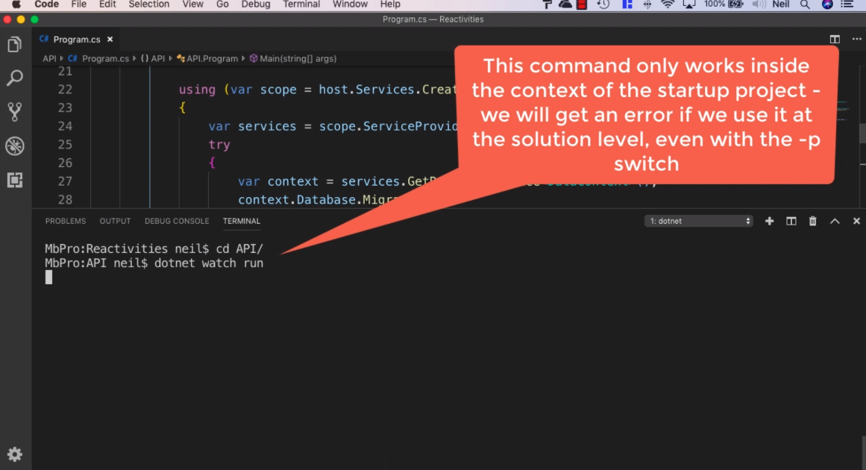

Adding SeedValue

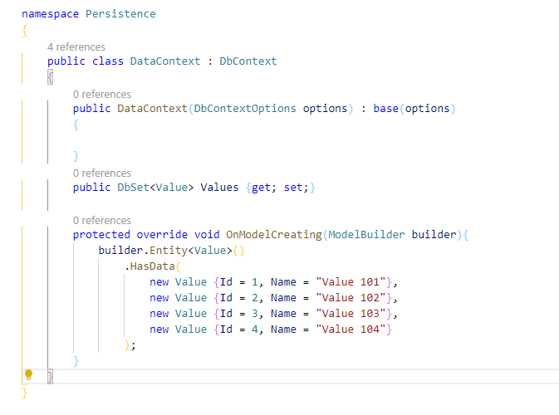

dotnet ef migrations add SeedValues --project Persistence/ --startup-project API/

dotnet ef migrations remove --project Persistence/ --startup-project API/ --force